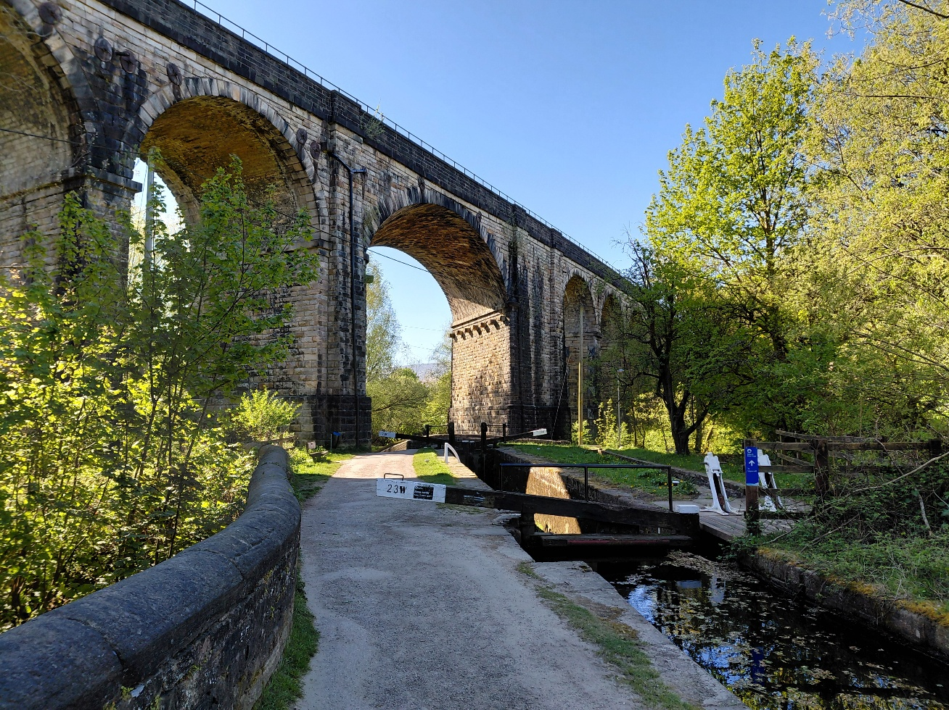

Uppermill Viaduct and Lock 23W - facing the northern side of the Viaduct

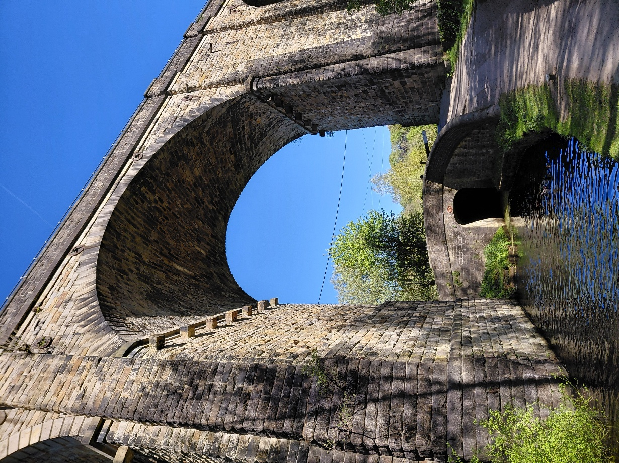

Uppermill Viaduct and bridge75 – facing the southern side of the Viaduct
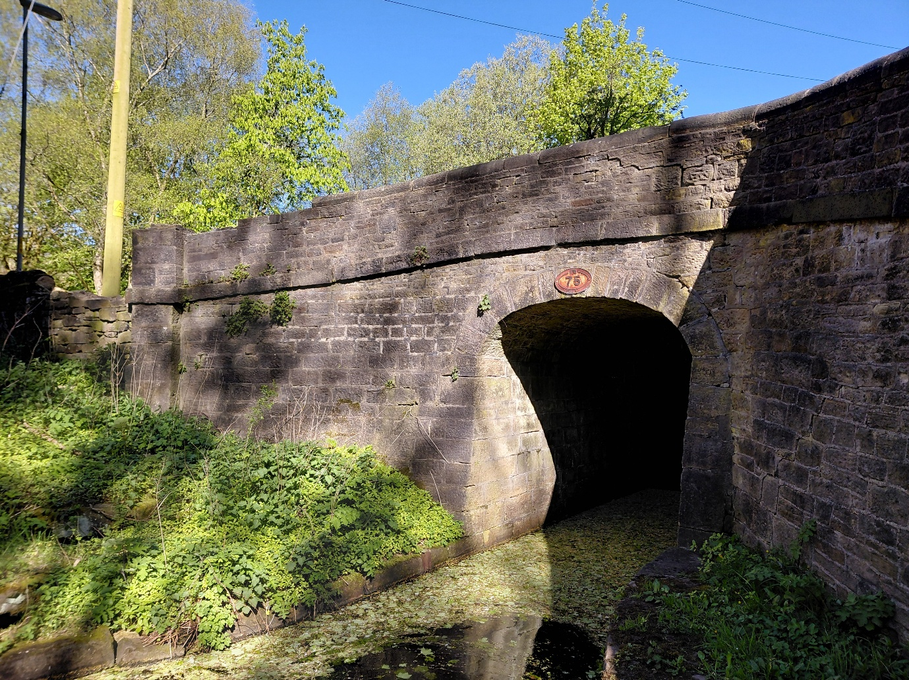

Bridge 75 – facing the southern side of the bridge.

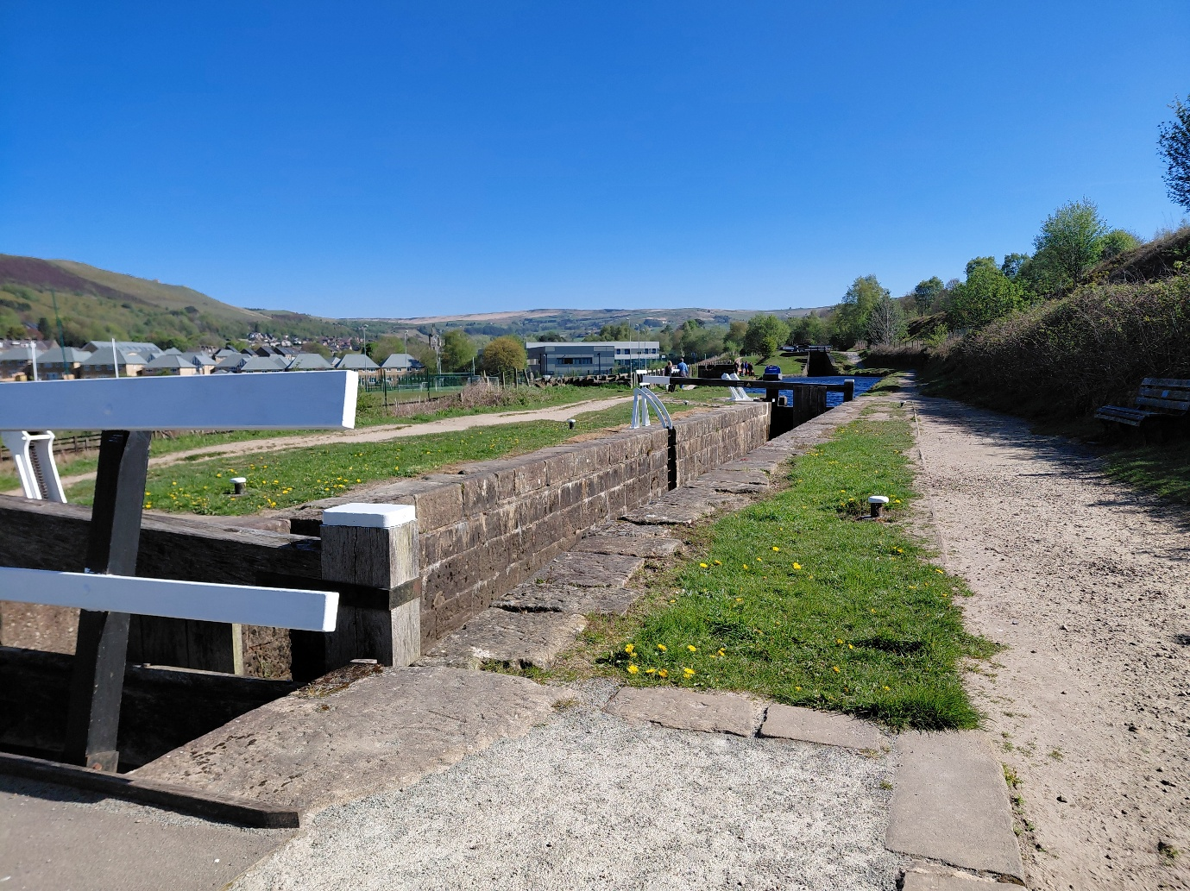

Lock 29W – relating to plot 17-004A

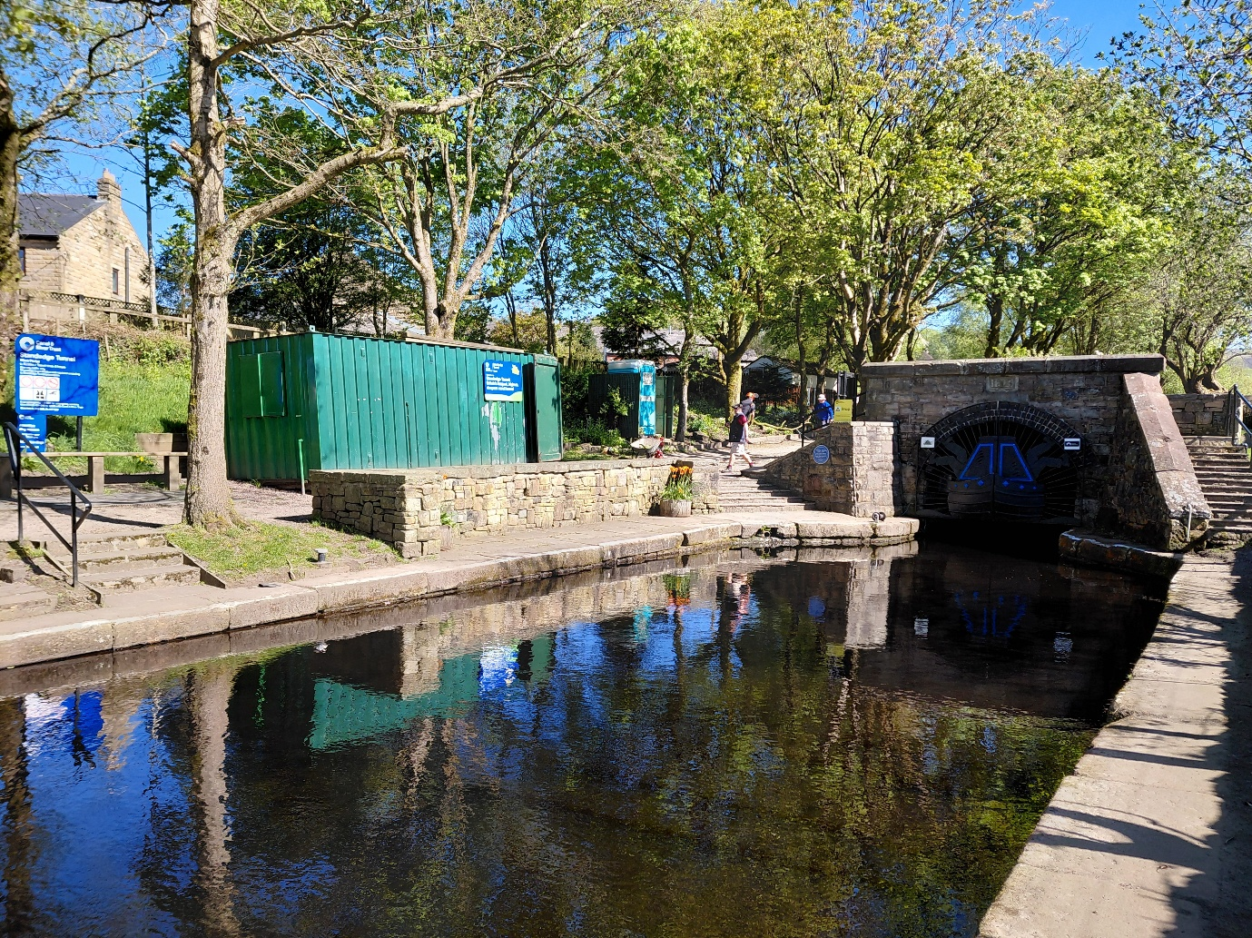
The Standedge Tunnel western portal (Diggle) including the Trusts storage container

