The below map extracts were taken from those readily available from the Maps section of the National Library of Scotland Website on the 29th April 2026.
From the map:
Yorkshire CCLXXI.NW
Series: Ordnance Survey Six-inch to the mile
Surveyed: 1889 to 1890
Published: 1894
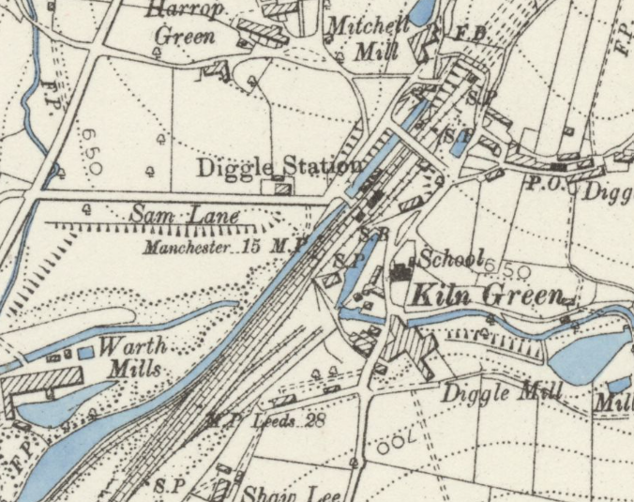
The canal can be seen flowing roughly on the line of the current tunnel passed the location of the proposed slab up to the original tunnel portal.

From the map:
Yorkshire CCLXXI.NW
Series: Ordnance Survey Six-inch to the mile
Revised: 1904
Published: 1907
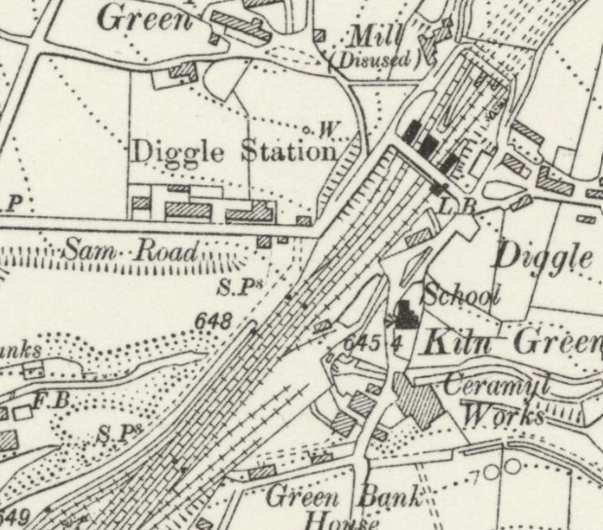
The tunnel arrangement as we know it today can be seen with no development on the surface along the line of the tunnel, particularly from Sam Road to the tunnel portal.

From the map:
Yorkshire CCLXXI.NW
Series: Ordnance Survey Six-inch to the mile
Revised: 1929
Published: 1933
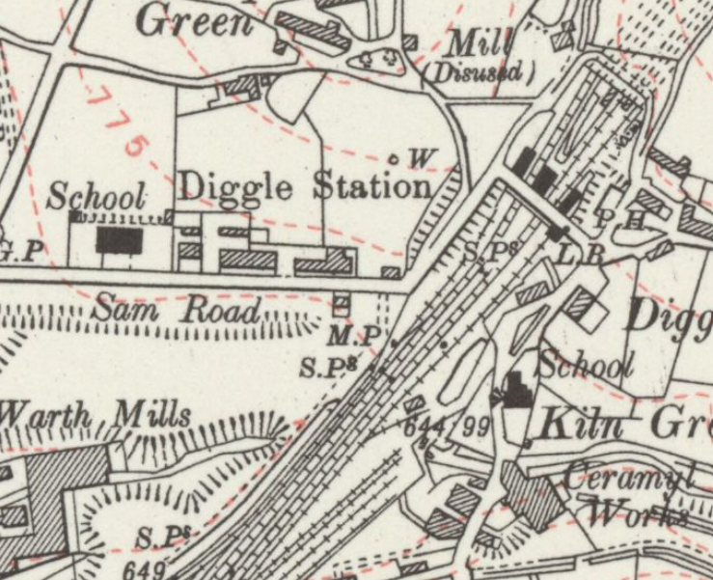
The tunnel arrangement as we know it today can be seen with no changes on the surface along the line of the tunnel noted since the previous revision of the map, particularly from Sam Road to the tunnel portal.

From the map:
Yorkshire CCLXXI.NW
Series: Ordnance Survey Six-inch to the mile
Revised: 1948
Published: 1949
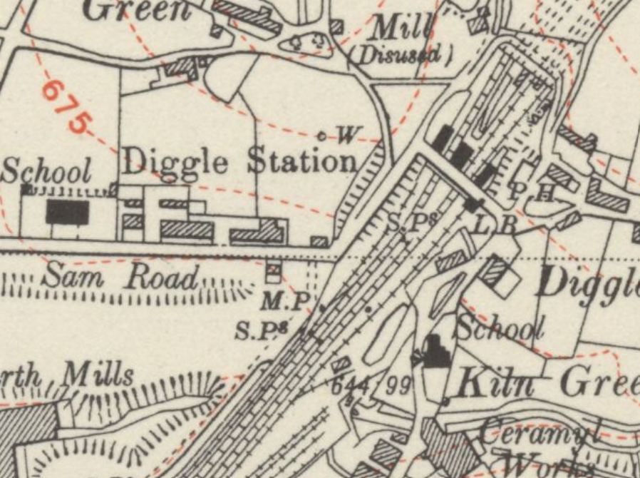
The tunnel arrangement as we know it today can be seen with no changes on the surface along the line of the tunnel noted since the previous revision of the map, particularly from Sam Road to the tunnel portal.

From the map:
SE0007 - A
Series: Ordnance Survey, 1:2500
Revised: 1951
Published: 1952
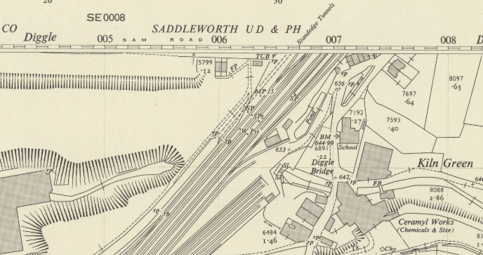
The tunnel arrangement as we know it today can be seen with no changes on the surface along the line of the tunnel noted since the previous revision of the map, other than a new structure South of Sam Road, but outside the zone of influence of the tunnel.

From the map:
SE0007-SE0107 - BA
Series: Ordnance Survey, 1:2500
Revised: 1963
Published: 1965
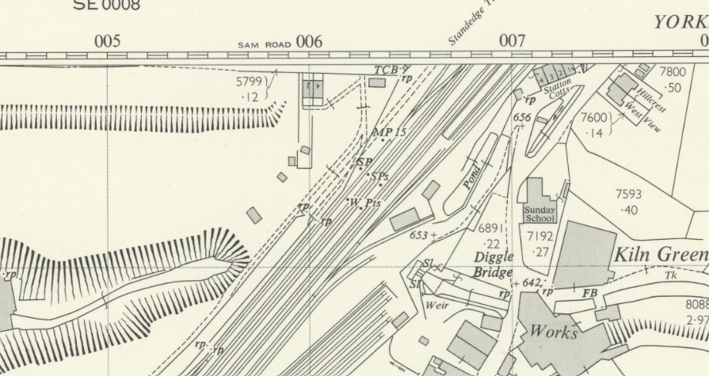
The tunnel arrangement as we know it today can be seen with no changes on the surface along the line of the tunnel noted since the previous revision of the map.

From Google Street View June 2009
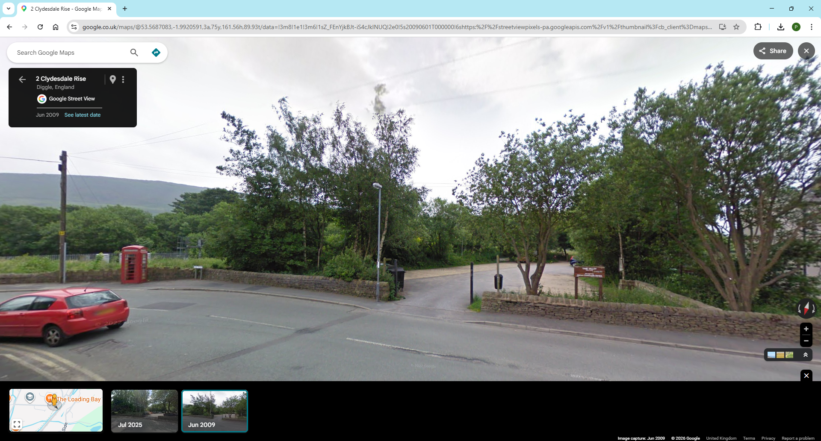
No development over the line of the tunnel

From Google Street View July 2025
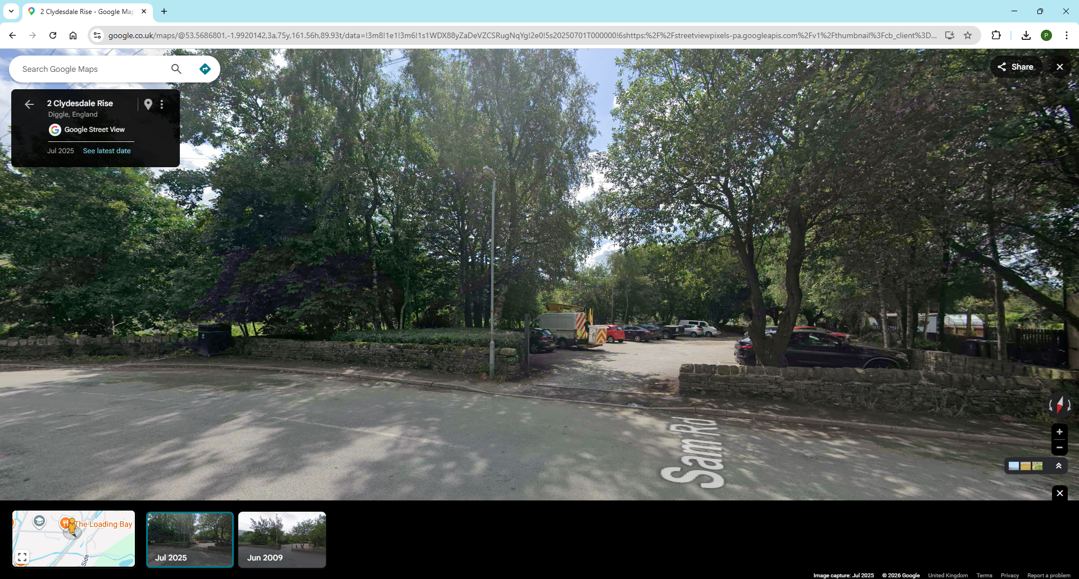
No development over the line of the tunnel

