The following extracts are taken from CIRIA C671 Tunnels: Inspection, Assessment and Maintenance
From the Glossary:
(Page xxviii) 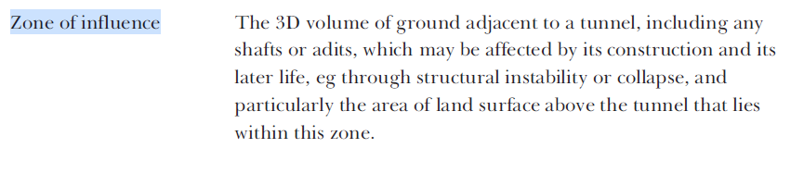
(Page 61)
